Abstract

This study aimed to investigate how nitrogen, phosphorus, and temperature levels influence the growth, and competitive hierarchies between *N. ditissima* and *N. faginata*. Our results revealed that nitrogen concentration had a significant negative effect on the growth rate of both species, while phosphorus concentration did not exhibit a significant effect on the individual growth. Regarding mycelial interactions, *N. ditissima* displayed a competitive advantage over *N. faginata*, occupying a larger proportion of the plate and exhibiting greater growth across all nutrient and temperature combinations. Phosphorus had a significant effect on the outcome of mycelial interactions, suggesting *N. faginata* may become more efficient at resource utilization when in contact with its congeners. Our findings suggest that both species may be ecologically equivalent according to nutrition-based in-vitro responses which indicates that neutral dynamics, may play a crucial role in the co-occurrence and dominance of *N. faginata* over *N. ditissima* in the BBD system.

**Keywords:**

*Neonectria ditissima*; *Neonectria faginata*; multi-species disease complex; nitrogen; phosphorus; temperature; in-vitro assays; pathogenic fungi

1. Materials and Methods

***Sample collection and storage***

Fungal isolates were collected from across the range of BBD as part of a previous study and are part of the repository at Garnas lab (Morrison et al., 2021). It is important to note that all isolates in this repository were obtained from a single colony after dissecting one perithecium out of the bark sample taken from the different geographical regions, according to Stauder et al (2020).

Briefly, a spore solution was obtained by carefully crushing a single perithecium on sterile peptone (1g/l) poured on a watch glass and then adding this suspension to a microcentrifuge tube with 1200 µl peptone solution. This solution was then thoroughly mixed before plating 300 µl onto a malt-yeast agar (MYA) plate which was incubated at room temperature during 48 hours. After this time, a single colony was dissected from this plate and positioned over a sterile filter paper covering a new MYA plate. Past 4 weeks, the filter papered was carefully placed into a sterilized coin envelope and stored in a -20℃ freezer.

***Isolate selection and reactivation***

To account for the variation within isolates of the same species from different geographical origins, six *Neonectria* spp. isolates were selected from the Garnas lab collection using the quantile function in R v 4.2.2 (R core team, 2019) as follows: one *N. faginata* and one *N. ditissima* (each with two mating types) originally obtained from College Woods in Durham, New Hampshire and one *N. faginata* (mating type 1) and one *N. ditissima* (mating type 2) originally isolated from Gaudiner Knob, West Virginia (Table 1).

The selected isolates were reactivated one by one from the coin-enveloped stock cultures kept at -20℃ by taking a small piece of the filter paper with sterilized forceps and placing it in the middle of a MYA plate. These plates were labeled, sealed with parafilm, and incubated at room temperature for two weeks before being used for the experiments.

***Basal medium preparation***

The basal medium used in all experiments was modified from (Barua et al., 2012). Briefly, a macronutrient stock solution composed of 0.33 g/l of MgSO4 and 0.11 g/l of CaCl2 and a micronutrient stock solution made of ZnSO4 0.33 g/l, FeSO4 0.15 g/l, CuSO4 0.1 g/l, MnSO4 0.1 g/l, Na2MoO4 0.02 g/l, thiamine hydrochloride 0.5 g/l and Nicotinic acid 0.1 g/l were prepared separately to add every time a new batch of media was done. Glucose 22.22 g/l and agar 30 g/l were also added separately to the medium.

For the different levels of nitrogen to be tested, ammonium nitrate (NH4NO3) was added to the basal medium at three different concentrations: 0.4 g/l (high), 0.04 g/l (middle) and 0.02 g/l (low) while for phosphorus, potassium phosphate (KH2PO4) was added at: 3.33 g/l (high), 0.33 g/l (middle) and 0.02 g/l (low). For the two lower levels of each nutrient a separate stock solution was made to avoid weighting error associated with such low concentrations so that every time 25 ml of said solution were added to a litter of media.

These concentrations were based on the results of a preliminary experiment in which a screening of several levels of both nutrients were tested separately using the same basal medium described above and culturing one mating type of each fungal species randomly selected from the six isolates reactivated (Appendix 1).

**Table1.** Information on the original sites where the fungal isolates used in the present study were obtained.

|  |  |  |  |  |  |  |  |  |  |  |  |  |
| --- | --- | --- | --- | --- | --- | --- | --- | --- | --- | --- | --- | --- |
| Isolate | | Location | County | State | Year sampled | Latitude | Longitude | Minimum temperature (℃) | Maximum Temperature  (℃) | | | Mean annual temperature  (℃) |
| Nd-MAT1 | Woodman Farm | | Strafford | NH | 2021 | 43.15271 | -70.9401 | 2.5 | | 14.3 | 8.4 | |
| Nd-MAT2 | Thompson Farm | | Strafford | NH | 2021 | 43.11093 | -70.9495 | 2.5 | | 14.3 | 8.4 | |
| Nf-MAT1 | College woods | | Strafford | NH | 2019 | 43.13399 | -70.9510 | 2.5 | | 14.3 | 8.4 | |
| Nf-MAT2 | College woods | | Strafford | NH | 2019 | 43.13399 | -70.9510 | 2.5 | | 14.3 | 8.4 | |
| Nd-MAT2 | Gaudineer Knob | | Randolph | WV | 2018 | 38.60741 | -79.8443 | 1.0 | | 12.9 | 7.0 | |
| Nf-MAT1 | Gaudineer Knob | | Randolph | WV | 2018 | 38.60741 | -79.8443 | 1.0 | | 12.9 | 7.0 | |

***Growth rate experiment***

The effects of nitrogen and phosphorus concentrations on growth of the six *Neonectria* spp. isolates were evaluated using a 3x3x2 factorial treatment structure in which three levels of each nutrient (high, middle, and low) and their possible combinations (Table 2) were assessed under two temperatures (10℃ and 15℃). Isolates (three per species: two from NH and one from WV) were considered as a biological replicate of each species, however each isolate was also plated in duplicate (technical replicate) per treatment per temperature (Balouiri et al., 2016). Briefly, a small fungal plug (of approximately 5 mm diameter) was obtained with a cork borer from the MYA stock cultures and individually placed in the middle of a 90 mm petri dish containing the basal medium agar. These plates were then sealed with parafilm and incubated at 10℃ and 15℃ for six days. After this time, the diameter of the fungal colony were measured using a digital caliper (Mitutoyo 500-196-30) every two days for 20 days (Hendricks et al., 2017). This experiment was repeated three times (Appendix 2, Figure I).

**Table2.** Treatments used for the three experiments on this study. Each treatment represents a combination of nitrogen (N) and phosphorus (P) concentrations. In the growth and competition experiments these same treatments were applied at 10℃ and 15℃. Similarly in the reproduction experiments these combinations were used at 15℃ and 20℃

|  |  |  |
| --- | --- | --- |
| Treatment | N concentration (g/l) | P concentration (g/l) |
| 1 | 0.02 | 0.03 |
| 2 | 0.02 | 0.33 |
| 3 | 0.02 | 3.33 |
| 4 | 0.04 | 0.03 |
| 5 | 0.04 | 0.33 |
| 6 | 0.04 | 3.33 |
| 7 | 0.4 | 0.03 |
| 8 | 0.4 | 0.33 |
| 9 | 0.4 | 3.33 |

***Competition experiment***

To see how the two species of *Neonectria* spp. interacted when grown together under different nutrient concentrations, the same design and treatments used for the individual experiments were applied. However, to ensure a balanced design between isolates two sets of competing pairs were formed. Pair 1 consisted of *N. ditissima* MAT2 and *N. faginata* MAT1 from NH while pair 2 comprised *N. ditissima* MAT2 and *N. faginata* MAT1 from WV. The culturing of these isolates was done following standard techniques (Klepzig & Wilkens, 1997). Briefly, each isolate was plated on a 60 mm petri dish by taking a small fungal plug (of approximately 5 mm of diameter) from the MYA stock culture and placed exactly at the border of the plate opposite to one another. These plates were then sealed with parafilm and incubated at 10℃ and 15℃ for six days. After this time, the long and short diameters of each species colony were measured using a digital caliper (Mitutoyo 500-196-30) every two days for 20 days. Additionally, the proportion of the plate (percentage of the total available plate area) occupied at day 20 was calculated for each species (Appendix 2, Figure III).

Mycelial interactions were described according to Rayner and Boddy (1988), with modifications (Figure 1). When the mycelia of either species invaded past the middle of the plate and invasion stopped within a few millimeters from each other this was defined as inhibition deadlock (ID). When the mycelia of both fungi completely intermingled with each other this was defined as competing deadlock (CD). When the mycelia of either fungus covered the colony of the other, this was defined as overgrown (O). When neither species grew past the middle of the plate this was defined as no contact (NC). Each pair of competing isolates had three sub replicates (technical reps) per treatment per temperature and the whole experiment was repeated three times.

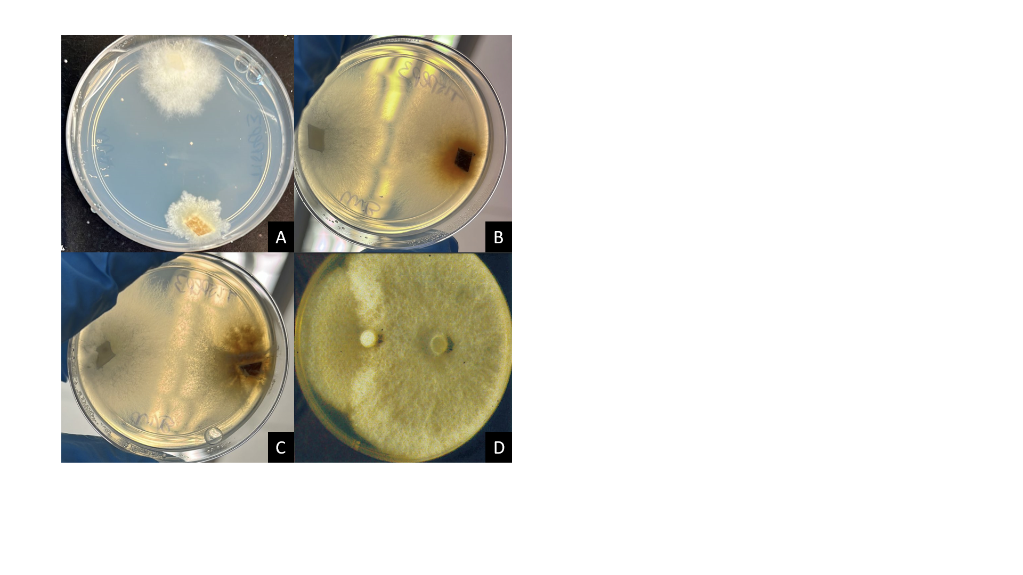

F**igure 1.** Mycelial interactions of paired *N. ditissima* (Nd)and *N. faginata* (Nf). Each species was inoculated facing each other and the outcome between them was evaluated after 20 days of incubation. We defined four possible outcomes as follows: (**A**) No contact (NC) between species, where colonies did not grow enough for a visible interaction to be assessed. (**B**) Inhibitory deadlock (ID) was defined when a visible inhibition zone was produced between colonies and there was no abundant growth at the lateral sides of the colonies. (**C**) Competitive deadlock (CD) was established when there was intermingling of the fungal mycelia but no overgrowth of either species over the other. (**D**) Overgrowth (O) was defined when one of the fungus grew over the other crossing the middle of the plate. In the present study we did not observe this interaction so the picture was obtained from Boddy et al., 2000.

***Statistical Analyses***

For the growth rate experiment, the long and short diameters were averaged for each day of measurement to get the total colony growth. Sub replicates were then averaged, and a linear regression model was applied to each culture to get a growth curve across the 20 days of incubation, the slope of which was reported as the growth rate (in mm per day).

To identify the model that accounted for most of the variation at the species level, several comparisons were conducted using analysis of variance (ANOVA) with all factors and their interactions included in a biologically meaningful manner. When the result of the ANOVA between two models yielded a significant p-value (p<0.05) between two models, the model that included the most interactions between factors was selected for further comparisons. In cases where no significant differences were observed between models, the simplest one was chosen. The final model’s assumptions of normality were assessed using a Shapiro-Wilk test (Shapiro & Wilk, 1965), examining the distribution of the residuals and using normal plots.

To compare the means of the categorical variables in the final model that had a significant effect (p<0.05) over the growth rate, Tukey’s honestly significant difference (HSD) test was conducted using the agricolae package within R v 4.2.2 (R core team, 2019). Additionally, an effect analysis was performed to assess the magnitude and direction of the continuous variables that had a significant effect over the response variable.

For the competition experiment the same procedures described above were followed to calculate the growth rate for each isolate (in mm per day). ANOVA was performed using the same final model as before, to evaluate the effect of the different factors on growth rate and the proportion of the plate occupied. In both cases, normality was tested using a Shapiro-Wilk test (Shapiro & Wilk, 1965), inspecting the distribution of the residuals of the model and using normal plots. Post-hoc analyses were performed to compare the means of the categorical variables that showed significance (p<0.05), using Tukey’s honestly significant difference (HSD) test. Additionally, an effect test was performed to assess the magnitude and direction of the continuous variables that had a significant effect over each response variable. Finally, for the mycelial interactions, the frequency of each interaction across technical reps was calculated using R v 4.2.2 (R core team, 2019). A logistical analysis was performed using JMP software (version 16.0, SAS Institute Inc., Cary, NC, USA) to assess how the mycelial interactions were influenced by nitrogen and phosphorus. Finally, to find whether there was a correlation between the mycelial interactions and the growth rate of the fungi, we run a linear model with these two variables to then do a post-hoc Tukey test to assess for any significant differences between the different competition outcomes.

For each experiment, we tested for the effect of geographical origin, represented by the state where the isolates were obtained, on the growth rate. However we found that origin didn’t have a significant effect on growth of the individual cultures (*F* = 1.262; df = 1, 322; *p* = 0.262) nor for the competing pairs (*F* = 0.015; df = 1, 214; *p* = 0.903), consequently, we confirmed that isolates are biological replicates of the respective species. We therefore excluded geographical origin from the final model across experiments and here we present the results in terms of species. In addition, we compared models with and without the interactions of temperature and phosphorus with the other variables and found that there was no significant difference between them, therefore on the final model we did not include those interactions.